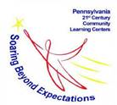
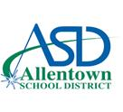
21st Century Community Learning Centers
After School Program - Cohort
2020-2021

Student Consent Form and Release of Information

Dear Parent/Guardian,
Thank you for your interest in the 21st Century virtual program! If you would like to enroll your student, please complete the information below and return it to (teacher leader email). We will contact you with your child’s start date. Placement is dependent on available spots so please be aware that your child may be placed on a waiting list. If you have any questions, please contact David George at (484) 765-4094 or georged@allentownsd.org.

Student Personal Information

Student Name: Student ID#:

School: Grade: Date of Birth:

Allergies:

Additional Information:

Parent/Guardian Name:

Phone Number: Email Address:

Consent/Release of Information

I hereby give permission for my child to be interviewed by a representative of Educational Enterprises, L.L.C. (2331 Pennsylvania Avenue, Philadelphia, PA19130) to evaluate the quality of the 21st Century Community Learning Centers Program.

Parent/Guardian Name (Printed Name):

Parent/Guardian Signature:

Funded in full or in part with a grant by the Pennsylvania Department of Education

